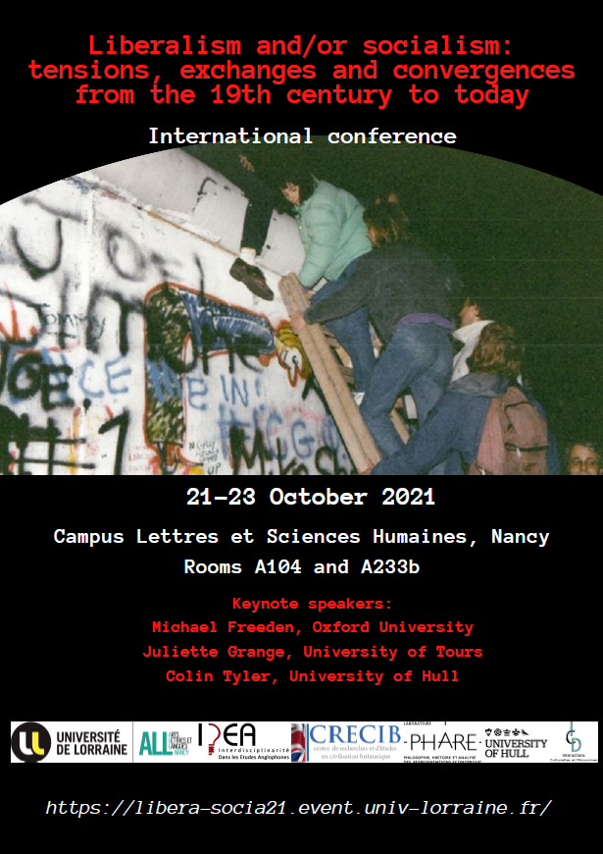
Organising committee
Vanessa Boullet, Stéphane Guy, Peterson Nnajiofor,
Ecem Okan, Jeremy Tranmer (IDEA - Interdisciplinarité dans les Etudes Anglophones), Université de Lorraine

Scientific committee
- Emmanuelle Avril, Université Sorbonne Nouvelle
- Emma Bell, Université Savoie Mont Blanc
- Fabrice Bensimon, Sorbonne Université
- Nathalie Champroux, Université de Tours
- Agnès Collier, Université de Bourgogne
- Louise Dalingwater, Sorbonne Université
- Jean Dellemotte, Université Paris 1 Panthéon Sorbonne
- David Jeffrey, University of Liverpool
- Stéphane Porion, Université de Tours
- Michel Prum, Université Paris Diderot
- Nathalie Sigot, Université Paris 1 Panthéon Sorbonne
- Peter Sloman, University of Cambridge
- Colin Tyler, University of Hull
- Anna Zielinska, Université de Lorraine

Thursday 21st October
8.30 am Welcome and registration

9 am Introduction (Room A 104)
Stéphane Guy (Université de Lorraine)
9.30 am Plenary session - Chair: James Thompson
(Room A 104)
Françoise Orazi (Université Lumière Lyon 2): Socialism and social liberalism: The state as a distinguishing feature?
Cornelius Crowley (Université Paris Nanterre): A series of debatable hypotheses
Fabien Tarrit (Université de Reims Champagne-Ardenne): Socialism against the state. Beyond the opposition between equality and liberty

10.50 am Break

11.10 am Plenary session - Chair: Peterson Nnajiofor (Room A 104)
André Pederson Ystehede (University of Leeds) Emilio Carnevali (Northumbria University):
Is socialism back?
Iason Zarikos (EKKE National Centre for Social Research): A utopian consensus: The growth ideal, the liberalization of socialism and the melancholy of politics
Alessandro Le Donne, Riccardo Soliani (University of Genoa): Commons, property rights, and liberalism. Is a “non-proprietary”, socialist individualism possible?

12.30 Break

1.45 pm Keynote – Chair: Stéphane Guy (Room A 104)
Michael Freeden (Oxford University): Liberalisms and socialisms: Recalibrating some analytical criteria
3 pm Parallel sessions

Panel 1A (Room A 104)  Chair: Sina Badiei | Panel 1B (Room A 233b)  Chair: Vanessa Boullet
Michel S. Zouboulakis (University of Thessaly): Mill and socialism: A reappraisal  Alexander Zevin (University of New York): Between liberalism and socialism: The case of John Stuart Mill  Virginie Gouverneur (Université de Haute-Alsace): John Stuart Mill and Harriet Taylor on the emancipation of women: Between liberalism and socialism | Robert Mason (University of Edinburgh): “Liberty versus socialism”: the US Republican Party and the politics of anti-socialism, 1933–1950  Stéphane Revillet (Université de Bourgogne Franche Comté): The Conservatives and their representation of socialism in the parliamentary discourse  François Deblangy (Université de Rouen-Normandie): Individual, free association and common ownership: A political identity for the British co-operative movement
4.20 pm Break

4.40 pm Parallel sessions

Panel 2 A (Room A 104)  Chair: Françoise Orazi | Panel 2 B (Room A 233b)  Chair: Emma Bell
Trevor Shelley (Arizona State University) and Ecem Okan (Université de Lorraine): Liberty and society before liberalism and socialism: On Adam Smith  Jean-Yves Tizot (Université de Grenoble): No lesser evil: John Ruskin against liberalism and socialism  Sina Badiei (Université Paris Lumières and Université de Lausanne): Unnecessary unhappiness as the basis of a Popperian critique of socialism and liberalism | Nicholas Sowels (Université Paris 1): Managerialism in government as the forced compromise between liberalism and socialism  Lovatiana Raveloarison (Université Sorbonne Nouvelle): British economic and social policies under Tony Blair: The third way or the art of navigating between progressive changes and conservative values?  Rafal Soborski (Richmond University): Prefigurative activism today: From socialist values via anarchist means to the neoliberal status quo
Friday 22nd October
9.30 am Plenary session – Chair: Cornelius Crowley
(Room A 104)

Sven Altenburger (University of Göttingen): Social liberal tax philosophies in Germany and America, c.1880 – 1910
James Thompson (University of Bristol): Debating democracy: Socialism, liberalism, and the foundations of politics in 1930s Britain
Simon Papaud (Université Lumière Lyon 2 – Université Picardie Jules Verne): From physiocracy to liberal socialism: Silvio Gesell's Freiwirtschaft's Third Way
10.50 am Break

11.10 am Plenary session – Chair: Jeremy Tranmer (Room A 104)
Max Ehrenfreund (Harvard University): The epistemology of regulation: Liberal economists and state power in Vienna, 1927–1938.
Maria Tumiotto (University of Manchester): “A synthesis between communism and fascism”: Subhas Chandra Bose’s Sāmyavāda as a non-western overcoming of ‘opposite’ ideologies
Anna Zielinska (Université de Lorraine): What went wrong with British socialism? The post-war United Kingdom through the lenses of Ralph Miliband
12.30 Break

1.45 pm Keynote – Chair: Anna Zielinska (Room A 104)
Juliette Grange (Université de Tours): The liberal basis of utopian socialism

3 pm Parallel sessions

Panel 3A (Room A 104)  Chair: Louise Dalingwater | Panel 3B (Room A 233b)  Chair: Jeremy Tranmer
Benoît Walraevens (Université de Caen-Normandie): Piketty’s struggle of ideologies and socialism  Dean Williamson (independent scholar): The provenance of an economics of adaptation  Nikolai G.Wenzel (Fayetteville State University): Can liberalism save itself from socialism by learning from It? | Peter Sloman (University of Cambridge): 'Since the 1960s we have seen state socialism in practice’: Jo Grimond, the Liberal Party, and the rise and fall of the UK’s post-war settlement  Gerardo Serra (University of Manchester): Conjoined crocodiles, inequalities and temporalities: J.B. Danquah on liberalism and socialism (Ghana, 1945-1965)  Niaz Cary-Pernon (Université Paul-Valéry Montpellier 3): Liberal socialism, empirical Idealism: The Labour Party and the international order from 1900 to 1939
4.20 pm Break

4.40 pm Parallel sessions

Panel 4A (Room A 104)  Chair: Peterson Nnajiofor | Panel 4B (Room A 233b)  Chair: Anna Zielinska
Louise Dalingwater (Sorbonne Université): A post-covid retreat from neoliberalism? The case of the NHS  Scott Scheall (Arizona State University): “Liberalism and / or socialism?” The wrong question? | Rodolphe Dos Santos Ferreira, Ragip Ege, Herrade Igersheim (Université de Strasbourg): What concept of freedom in Sismondi? An analysis in the light of social justice theories  Maria Dimova-Cookson (Durham University): Benjamin Constant and the liberalism of a happy revolution  Jean-Michel Yvard (Université d'Angers): Between liberalism and socialism: Darwinism and politics in David G. Ritchie (1853-1903)

Saturday 23rd October
9.30 am Keynote – Chair: Stéphane Guy (Room A 104)
Colin Tyler (University of Hull): Transcending liberalism and socialism: The institutional economics of class in British idealist thought and practice

10.30 am Break

10.50 am Plenary session – Chair: Stéphane Guy (Room A 104)
David Boucher (University of Cardiff): Social liberalism and the ‘Right’ kind of socialism
Janusz Grygieńć (Nicolaus Copernicus University): J.A. Hobson’s epistemic “re-statement of democracy”
Łukasz Dulęba (Adam Mickiewicz University): Is social liberalism possible? New liberalism and the problem of opposing political concepts

12.10 Conclusion (Room A 104)

2.30 pm Guided tour of the historical centre of the city of Nancy

